**Playwright**

**Playwright architecture:**

* Based on WebSocket protocol
* Bi-directional communication (once connection established, we can send as much as commands, until we close the connection)
* Faster as compared to http protocol

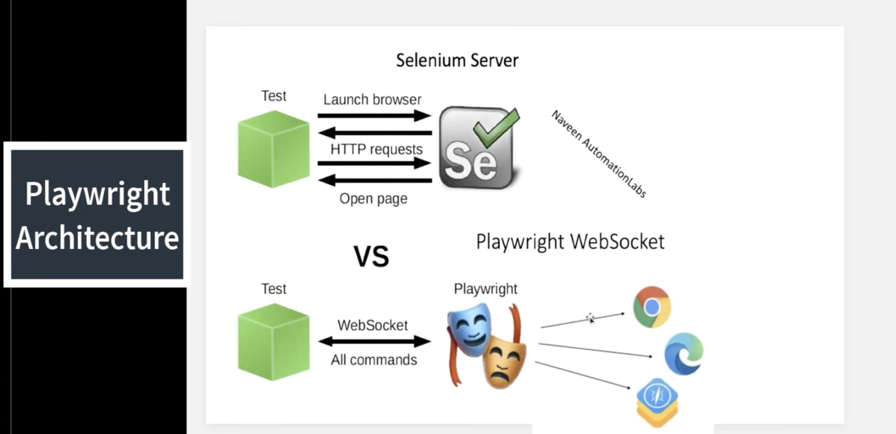

Playwright architecture is completely different from what Selenium architecture is. Both Selenium and Playwright use to send all browser automation commands and receive responses in JSON format.

Selenium uses separate HTTP requests for every command like launching the browser, opening the page, taking screenshots and so forth.

However, sending a new HTTP request for every command requires sending and receiving a lot of redundant information such as HTTP headers. Such approach tends to be slower than using one permanent communication channel for all commands which is alive while browser is running.

Playwright uses this approach and communicates with browser using one long-living web-socket connection. The web-socket connection gets established inside launch() method implementation which also automatically starts browser process for you.

Playwright has a lot of similarities with Puppeteer. In fact, the same team which developed Puppeteer, was behind the creation of Playwright at Microsoft.

**Playwright Feature**:

* Open source
* Designed for E2E testing.
* Easy installation
* Support multiple OS
* Support multiple languages.
* Support multiple browser
* Locally or on CI, headless or headed with native mobile emulation
* Playwright delivers full test isolation with no overhead. It creates a browser context for each test which only takes a handful of milliseconds.
* By default, Playwright runs the browsers in headless mode.
* Auto-wait capabilities
* Default time-out for test = 30s
* Default time-out for expect/assertThat =5s
* We can easily integrate UI+API
* Most of the feature comes by-default/in-built like: Screenshot, traces, video recording, retry capability.
* By default test files will execute parallel(default 5 workers), but tests inside single file will run sequential (this is specific to JS)
* Generate an HTML report to view test execution results in the browser. It contains visual mismatches and test artifacts like screenshots, traces, error logs, and video recordings (this is specific to JS)
* We can store browser state and use next onwards.
* Shadow DOM handle
* Frame handle
* Window/Tab handle
* Session storage/Local storage: The Playwright prevents the need for multiple logins. It stores the session details, including cookies, within a context. Therefore, it can be used across all tests within that particular context.
* Lot of ways to write locator
* In-built assertion capability
* Offers support for automated accessibility testing
* It provides different debugging options like Playwright Inspector, Browser Developer Tools, IDE Debugger, and Trace Viewers Console Logs.
* It has in-built reporters like JSON, JUnit, and HTML Reporters(specific to JS). With Playwright, you can also create custom reporters.
* Run parallel test execution locally or on an online Selenium grid. You can also share tests between systems to run multiple tests in parallel.
* Playwright assertions are created specifically for the dynamic web. Checks are automatically retried until the necessary conditions are met. Playwright comes with [auto-wait](https://playwright.dev/java/docs/actionability) built in meaning it waits for elements to be actionable prior to performing actions. Playwright provides [assertThat](https://playwright.dev/java/docs/test-assertions) overloads to write assertions.
* Documentation is really good.

**Playwright Disadvantages:**

* Less community support
* Playwright does not support legacy Microsoft Edge or IE11.
* Playwright uses desktop browsers instead of real devices to emulate mobile devices.

**Playwright works on three core concepts: browser, context, and page.**

* Browser: To run the tests, you must initiate the browser. Using Playwright, you can use the object of the Browser class, an instance of Chromium, Firefox, or Webkit.
* Context: The Playwright framework achieves parallelization using browser contexts. The browser contexts are like incognito-like profiles isolated within a browser instance. browser contexts will not share any cache/cookies to other browser contexts. A browser context is used to create an independent browser session. We can use multiple browser contexts to create separate browser sessions in a single Playwright test.
  + Playwright has the concept of a BrowserContext which is an in-memory isolated browser profile.
  + It's recommended to create a new BrowserContext for each test to ensure they don't interfere with each other.
  + Browser context won't share anything, not store cahes/cookies and always open in in-cognito.
  + Playwright and Browser instances can be reused between tests for better performance.
  + We recommend running each test case in a new BrowserContext, this way browser state will be isolated between the tests.
* Page: It is a new tab (or pop window) within a browser context. Every action on the test will be performed on the page.

**Assertion**: Playwright provides assertThat overloads which will wait until the expected condition is met.

assertThat(page).hasTitle(Pattern.compile("Playwright"));

assertThat(getStarted).hasAttribute("href", "/docs/intro");

assertThat(page).hasURL(Pattern.compile(".*intro"));

assertThat(page.locator("text=Installation")).isVisible();

assertThat(page.getByText("Welcome, John")).isVisible();

assertThat(page.getByTitle("Issues count")).hasText("25 issues");

assertThat(page.getByRole(AriaRole.LISTITEM).hasCount(3);

assertTrue(page.getByLabel("Subscribe to newsletter").isChecked());

Use [assertThat(locator).hasText()](https://playwright.dev/java/docs/api/class-locatorassertions" \l "locator-assertions-to-have-text) to ensure that the list has the text "apple", "banana" and "orange".

assertThat(page  
 .getByRole(AriaRole.LISTITEM))  
 .hasText(new String[] { "apple", "banana", "orange" });

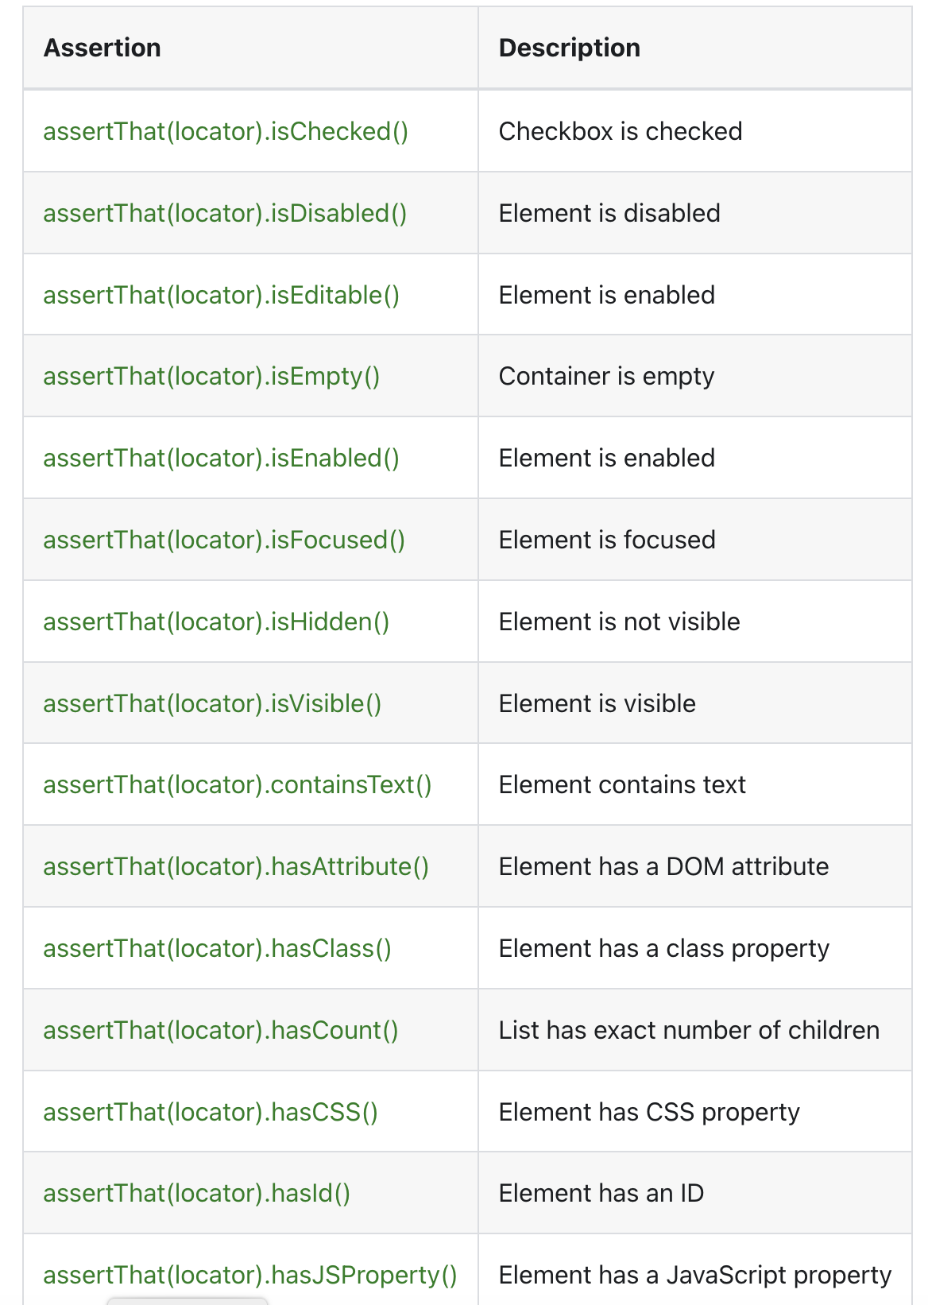

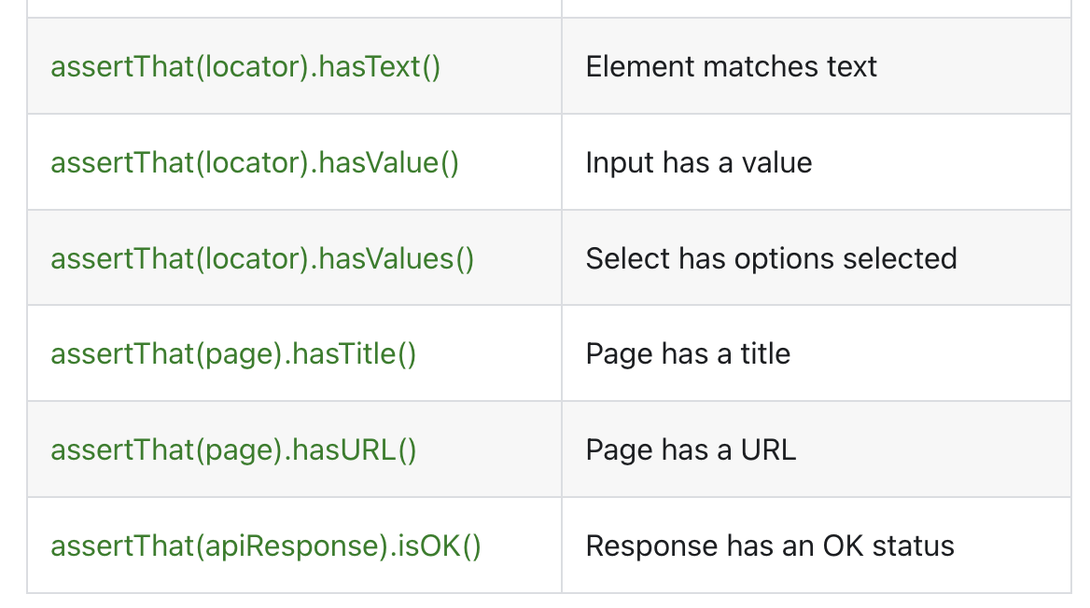

**Locator:** locators represent a way to find element(s) on the page at any moment.

These are the recommended built in locators.

* [Page.getByRole()](https://playwright.dev/java/docs/locators#locate-by-role) to locate by explicit and implicit accessibility attributes.
* [Page.getByText()](https://playwright.dev/java/docs/locators#locate-by-text) to locate by text content.
* [Page.getByLabel()](https://playwright.dev/java/docs/locators#locate-by-label) to locate a form control by associated label's text.
* [Page.getByPlaceholder()](https://playwright.dev/java/docs/locators#locate-by-placeholder) to locate an input by placeholder.
* [Page.getByAltText()](https://playwright.dev/java/docs/locators#locate-by-alt-text) to locate an element, usually image, by its text alternative.
* [Page.getByTitle()](https://playwright.dev/java/docs/locators#locate-by-title) to locate an element by its title attribute.
* [Page.getByTestId()](https://playwright.dev/java/docs/locators#locate-by-test-id) to locate an element based on its data-testid attribute (other attributes can be configured).

Playwright comes with multiple built-in locators. To make tests resilient, we recommend prioritizing user-facing attributes and explicit contracts such as [Page.getByRole()](https://playwright.dev/java/docs/api/class-page" \l "page-get-by-role).

Every time a locator is used for an action, an up-to-date DOM element is located in the page. In the snippet below**, the underlying DOM element will be located twice, once prior to every action**. This means that if the DOM changes in between the calls due to re-render, the new element corresponding to the locator will be used.

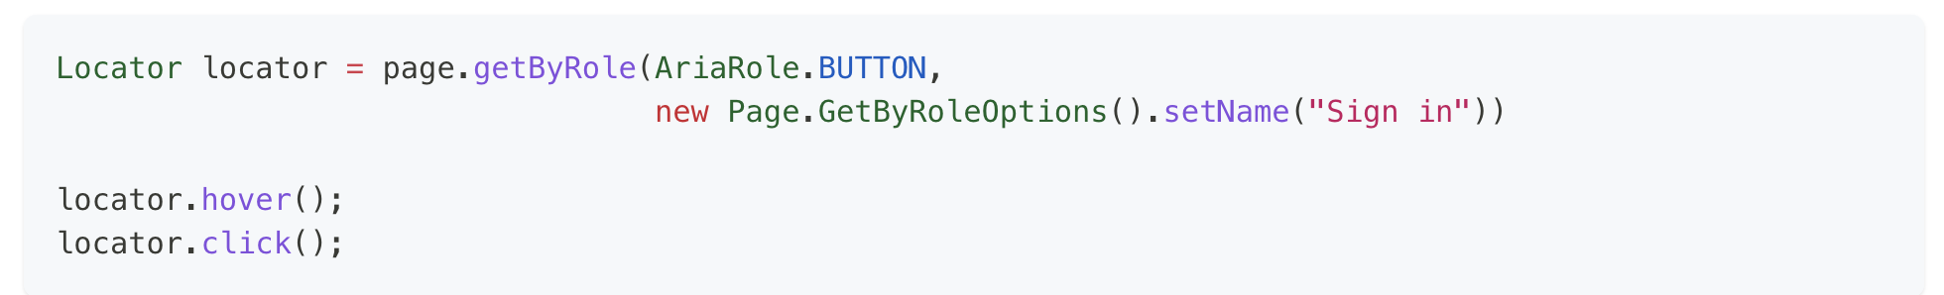

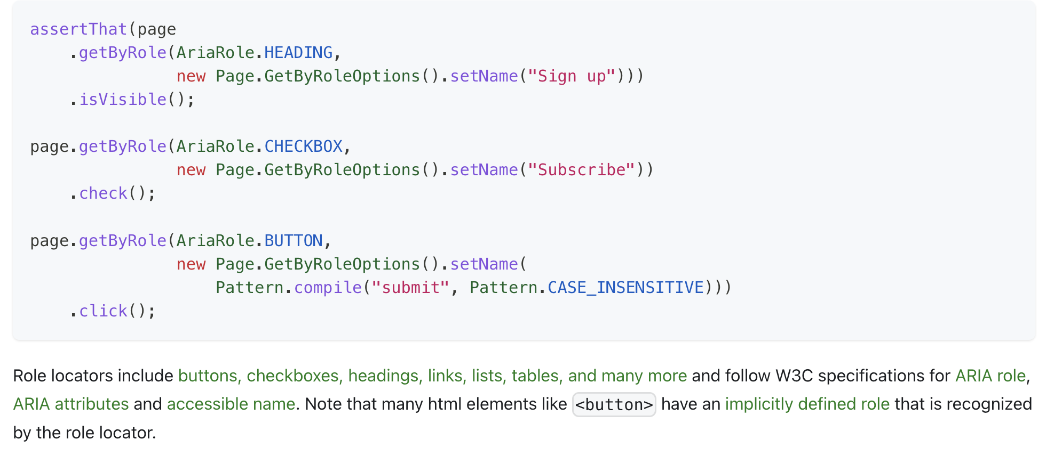

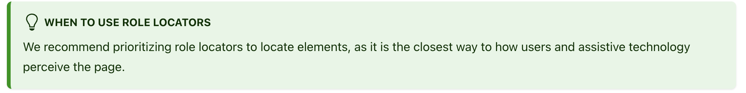

### Locate by CSS or XPath[​](https://playwright.dev/java/docs/locators#locate-by-css-or-xpath)

If you absolutely must use CSS or XPath locators, you can use [Page.locator()](https://playwright.dev/java/docs/api/class-page" \l "page-locator) to create a locator that takes a selector describing how to find an element in the page. Playwright supports CSS and XPath selectors, and auto-detects them if you omit css= or xpath= prefix.

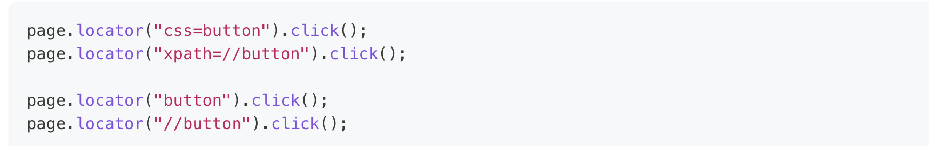

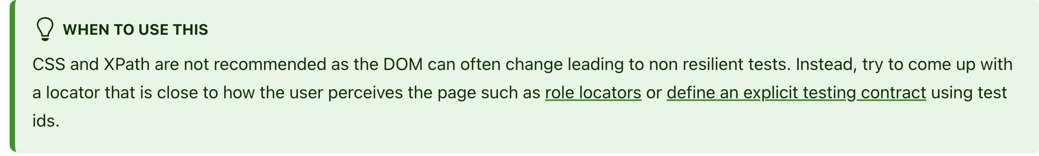

## **Locate in Shadow DOM**[**​**](https://playwright.dev/java/docs/locators#locate-in-shadow-dom)

All locators in Playwright **by default** work with elements in Shadow DOM. The exceptions are:

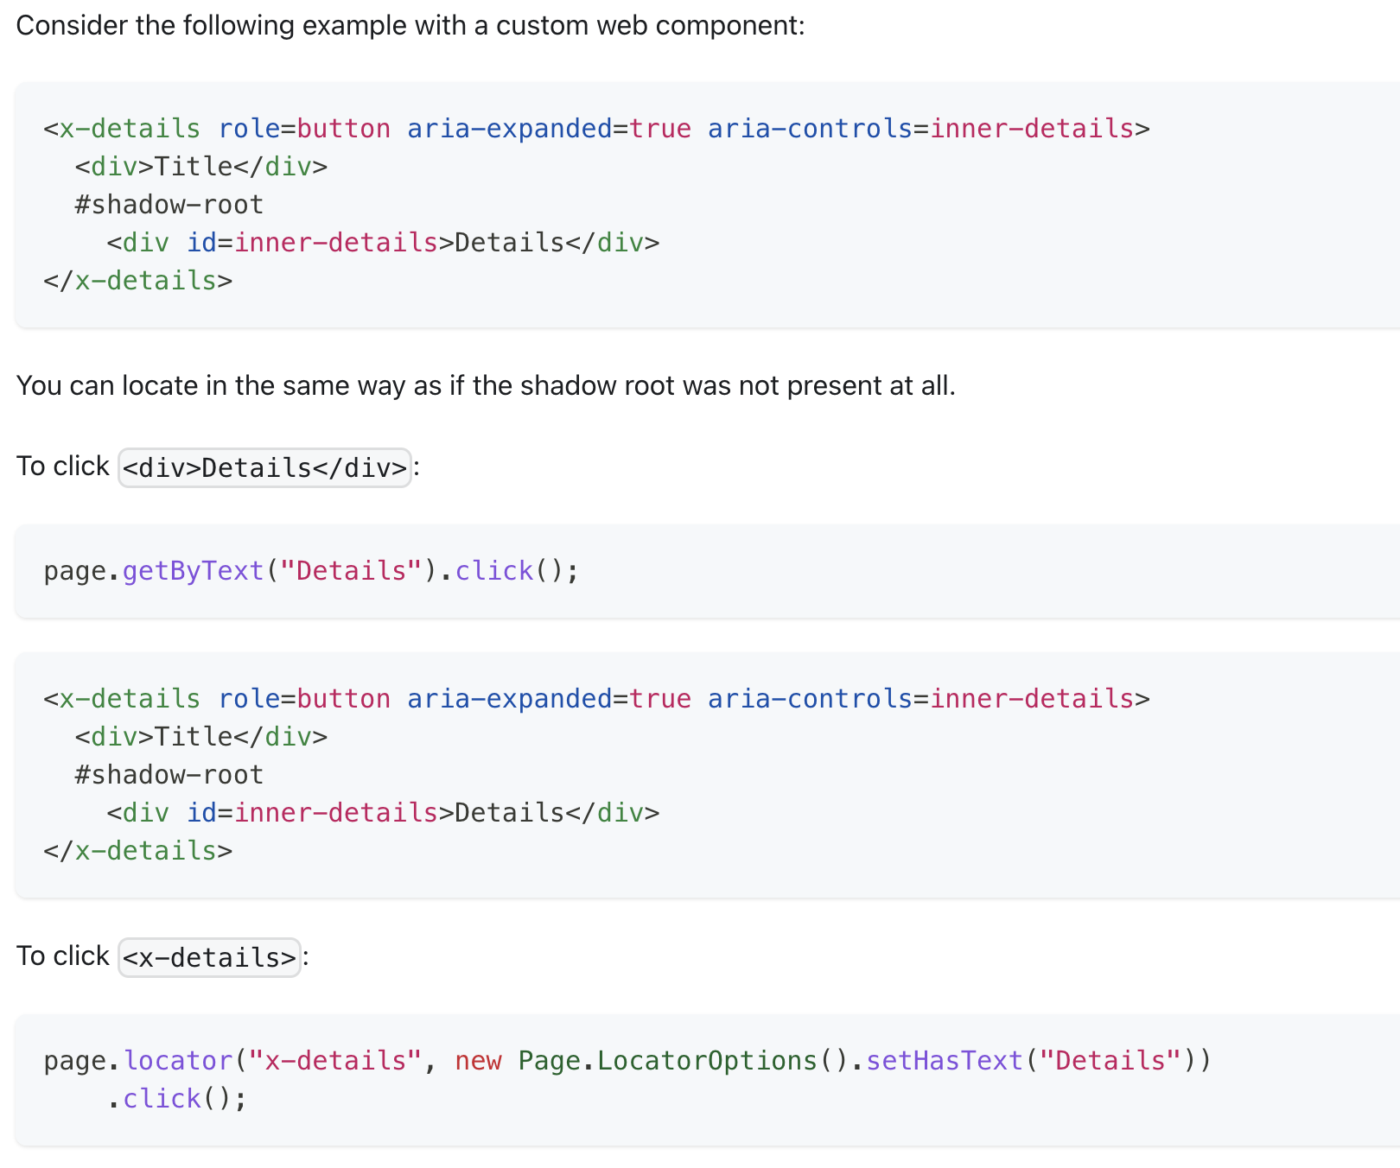

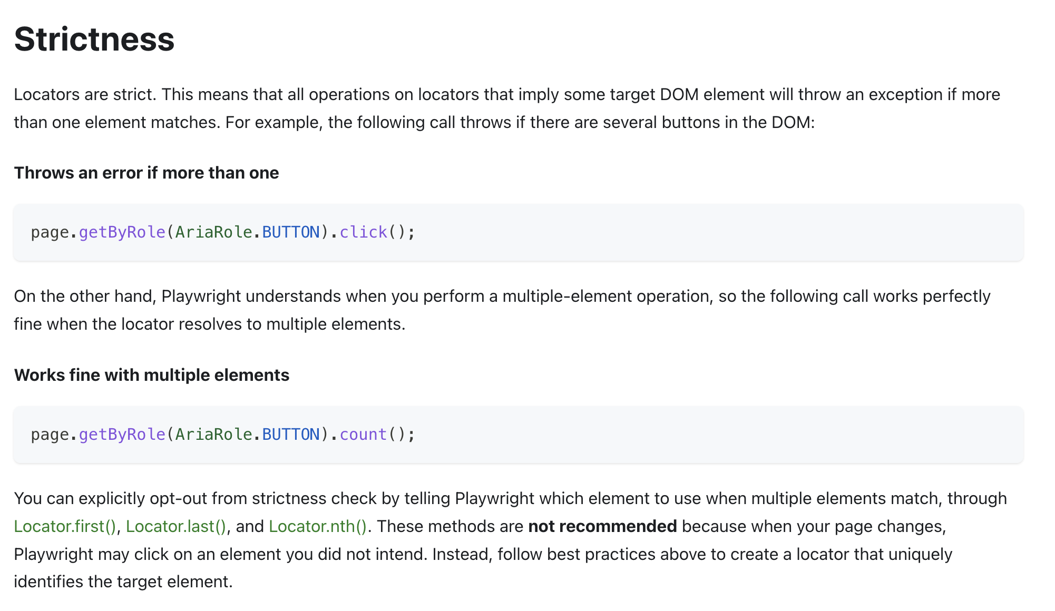

Always **avoid iterate a loop** to find a locator, not recommended, try to write unique locator.

There are lot of way to write locator apart from css/xpath, but that we can’t validate directly on dev tool, so we use **playwright codegen and browser console** to validate the locator. Meaning you must launch page using codegen.

mvn exec:java -e -D exec.mainClass=com.microsoft.playwright.CLI -D exec.args="codegen <https://magento.softwaretestingboard.com/>"

then open console, then only you will get playwright commands.

**$** : single element

**$$** : multiple element

Example:

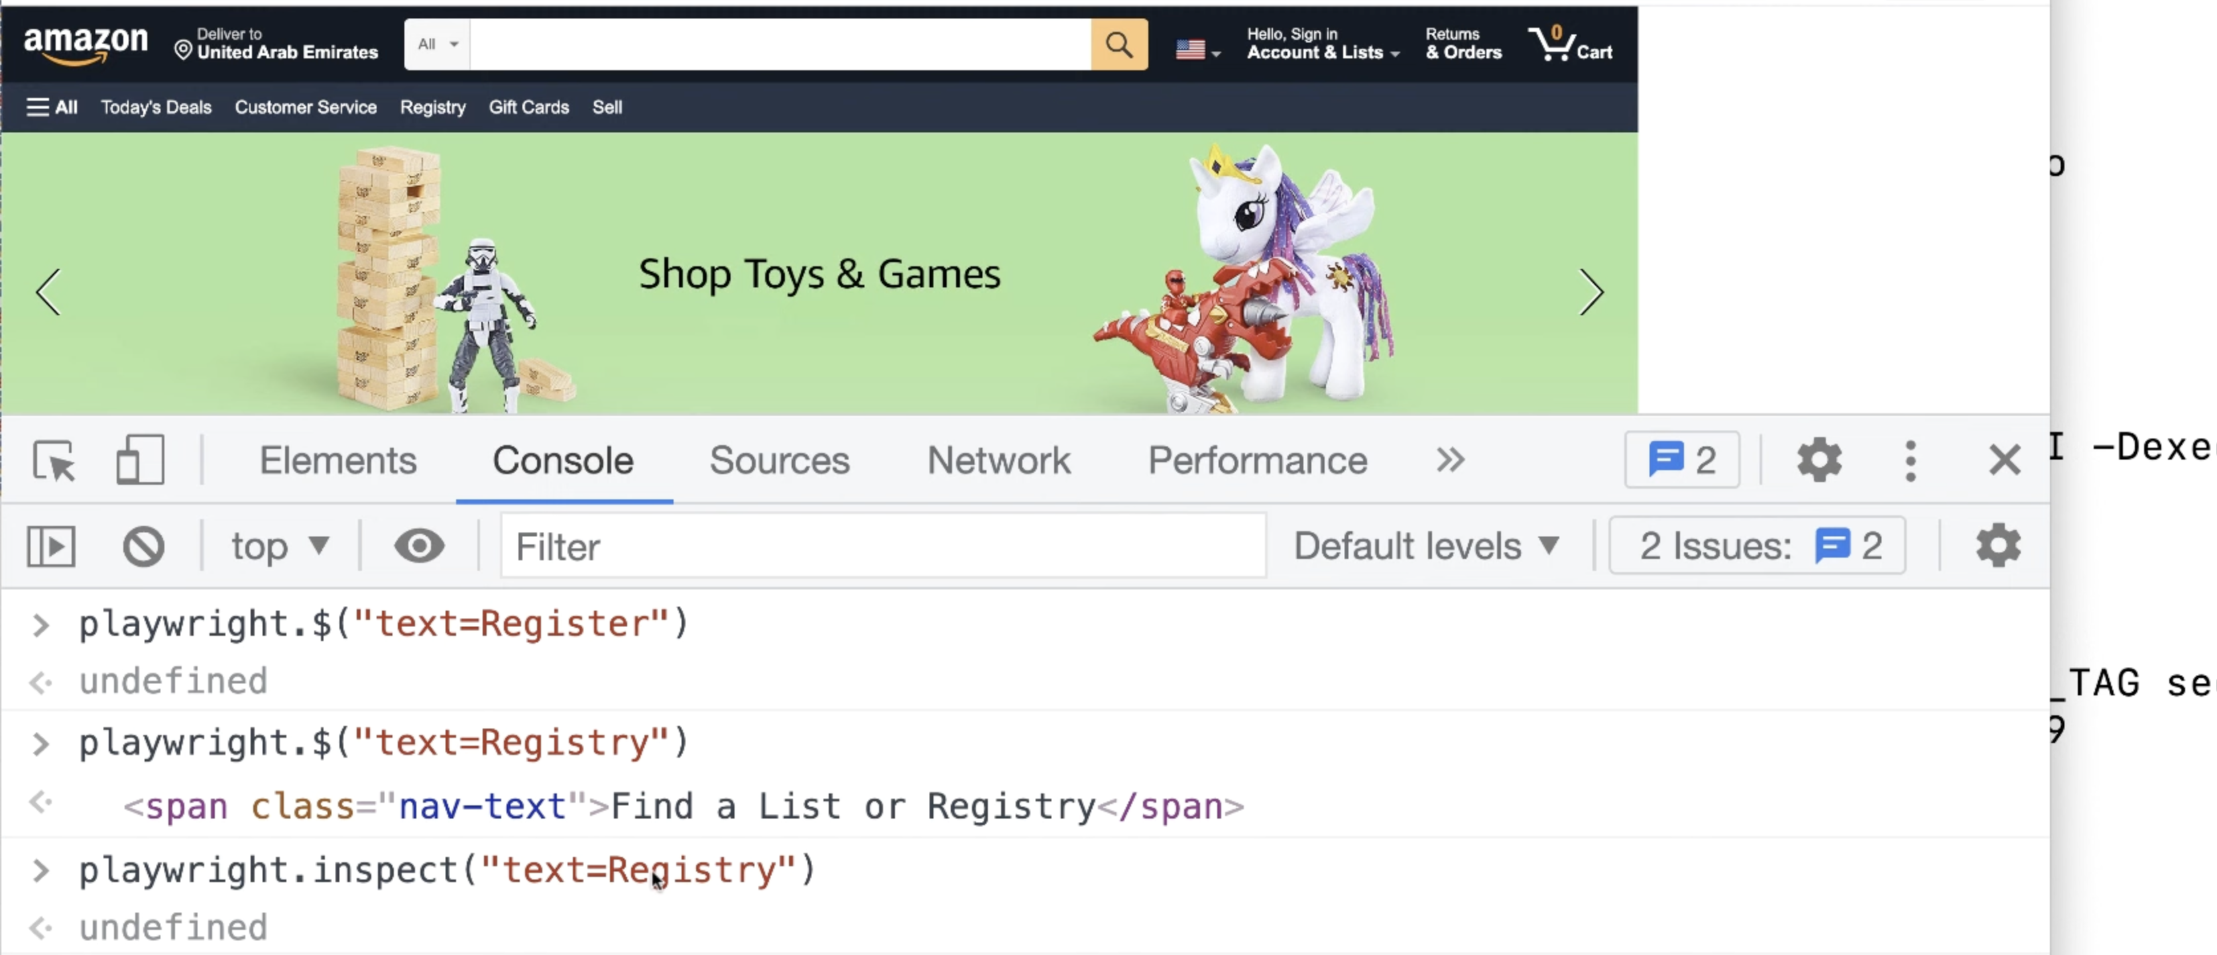

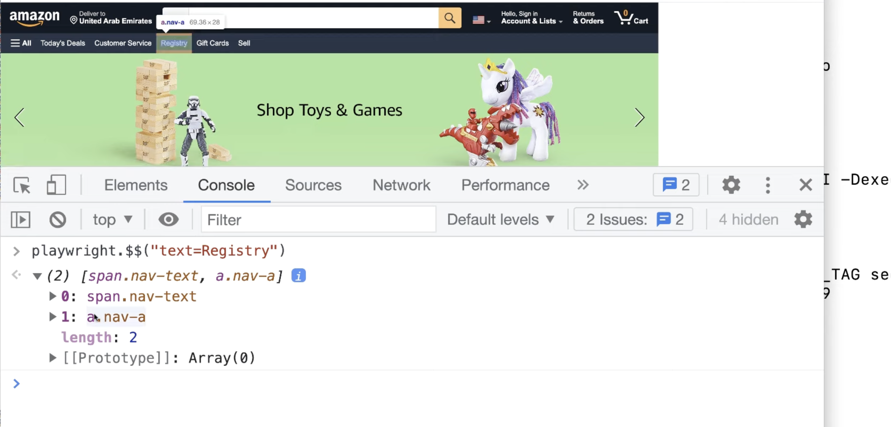

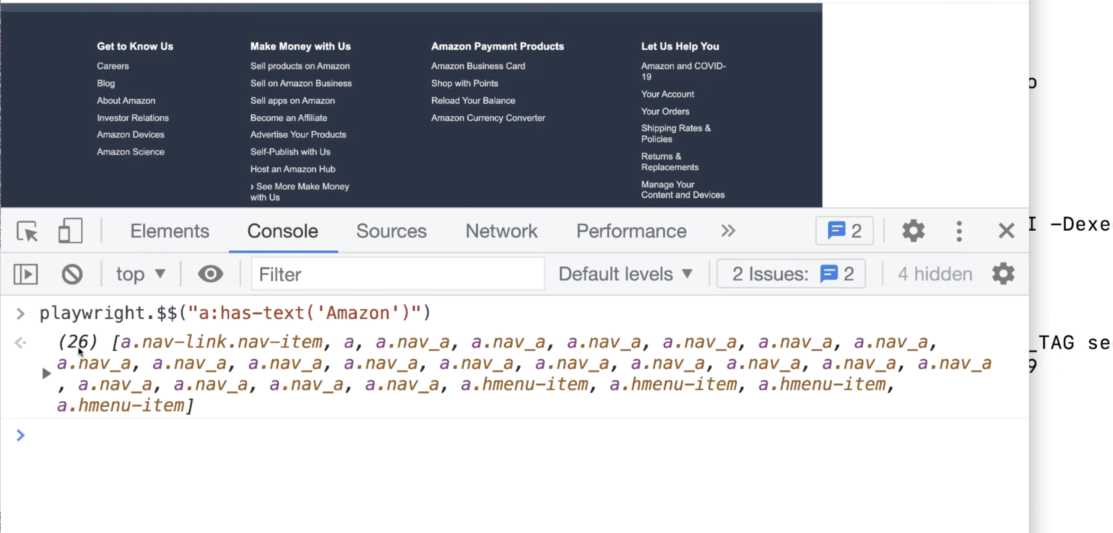

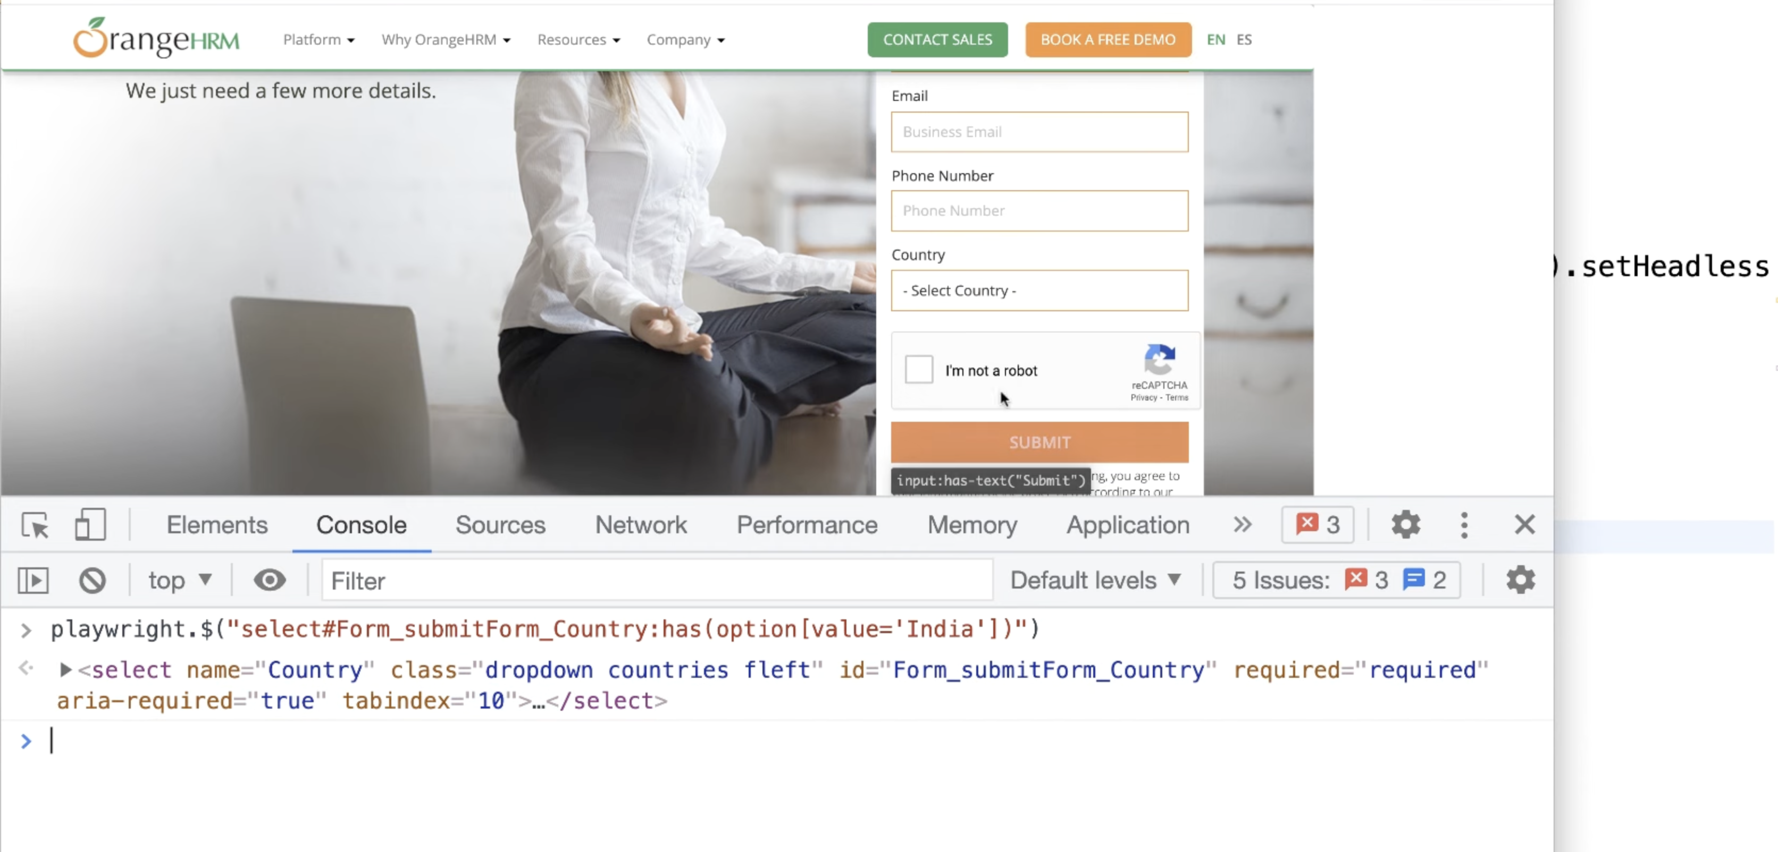

**Common Errors/Exceptions in playwright:**

com.microsoft.playwright.TimeoutError: Error {

message='Timeout 30000ms exceeded.

com.microsoft.playwright.PlaywrightException: Error {

message='Error: strict mode violation: getByText("Mouse Hover") resolved to 2 elements:

com.microsoft.playwright.PlaywrightException: Error {

message='Element is not visible

**Test Isolation**[**​**](https://playwright.dev/java/docs/writing-tests#test-isolation)

Playwright has the concept of a [BrowserContext](https://playwright.dev/java/docs/api/class-browsercontext" \o "BrowserContext) which is an in-memory isolated browser profile. It's recommended to create a new [BrowserContext](https://playwright.dev/java/docs/api/class-browsercontext" \o "BrowserContext) for each test to ensure they don't interfere with each other.

Playwright and Browser instances can be reused between tests for better performance. We recommend running each test case in a new BrowserContext, this way browser state will be isolated between the tests.

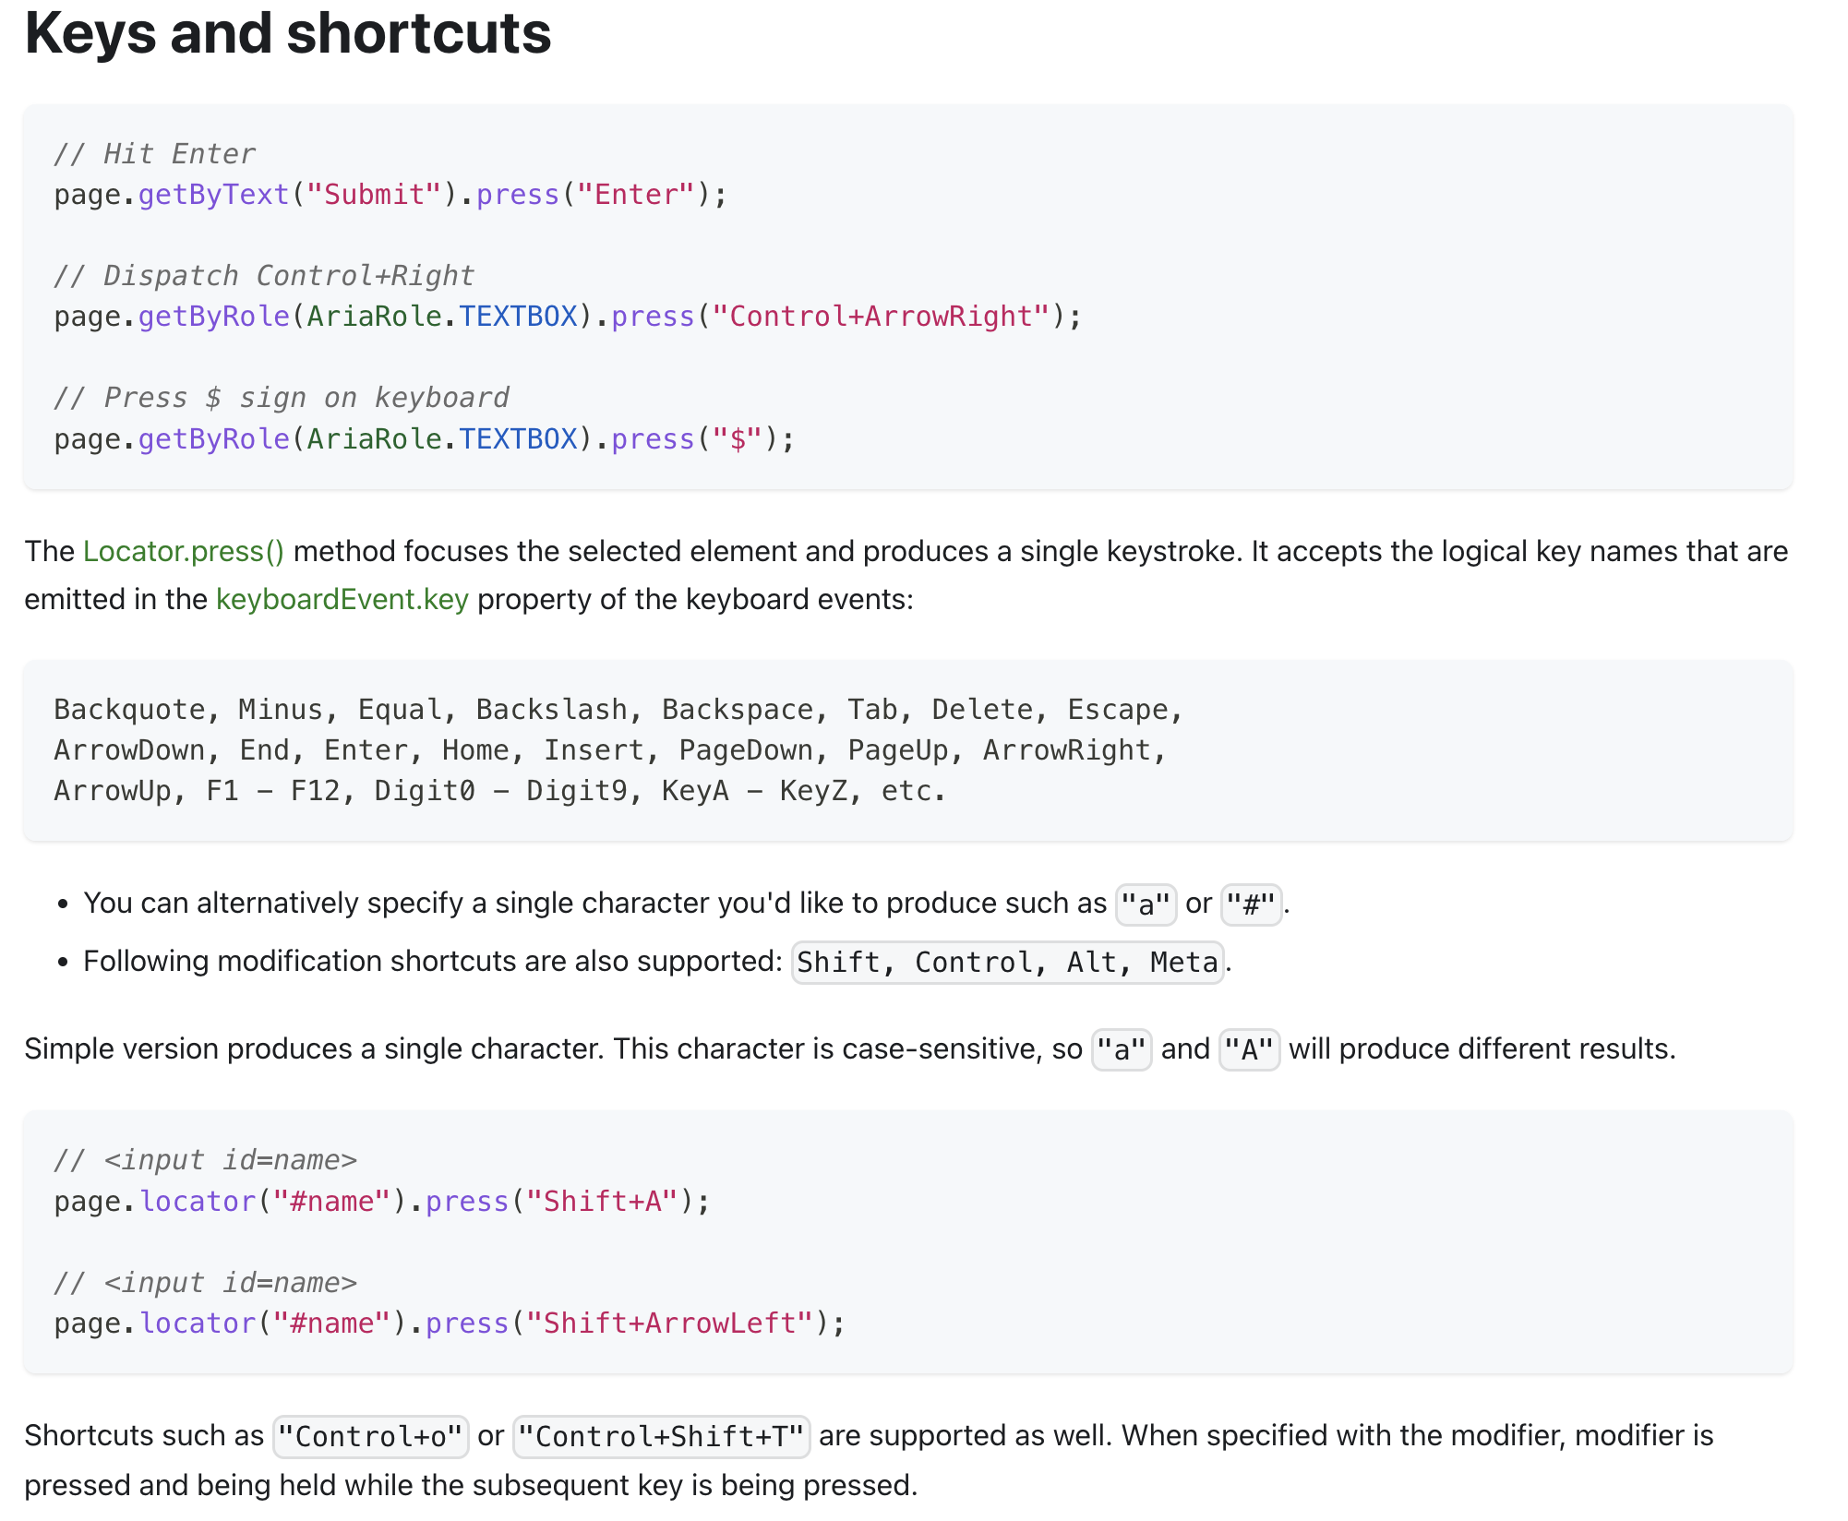

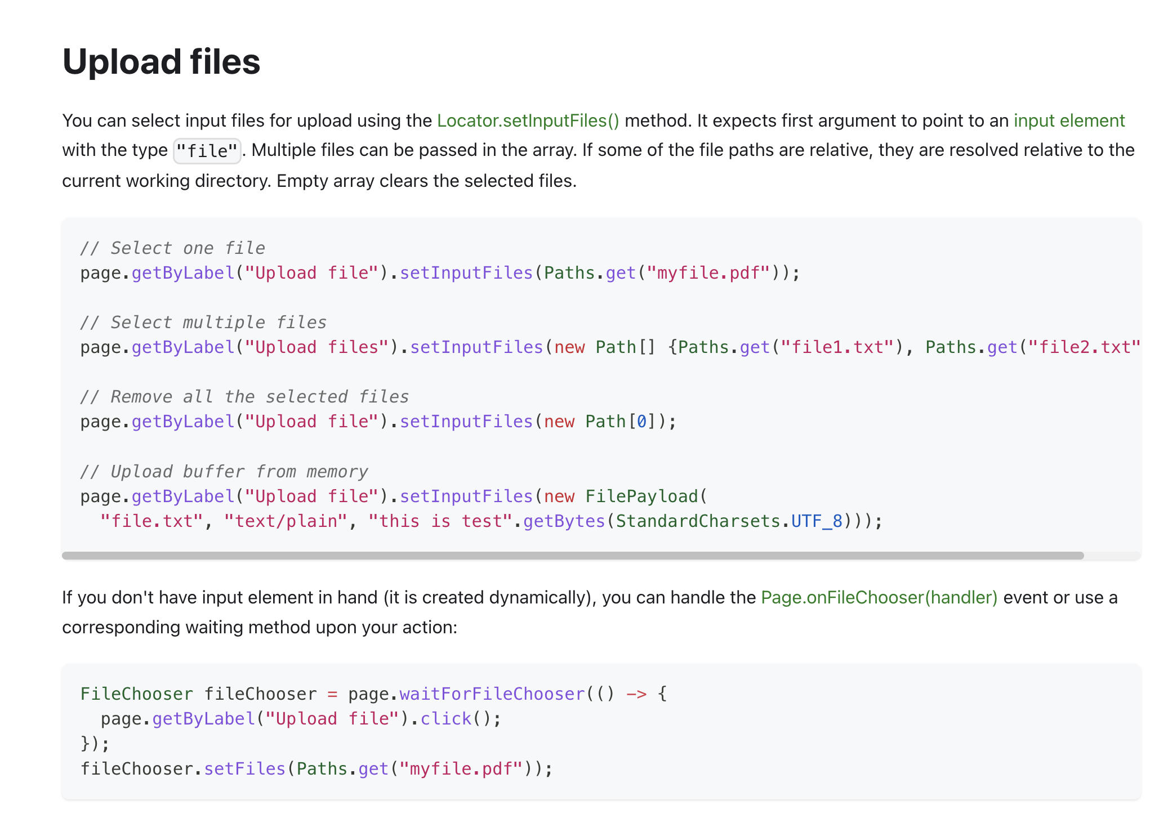

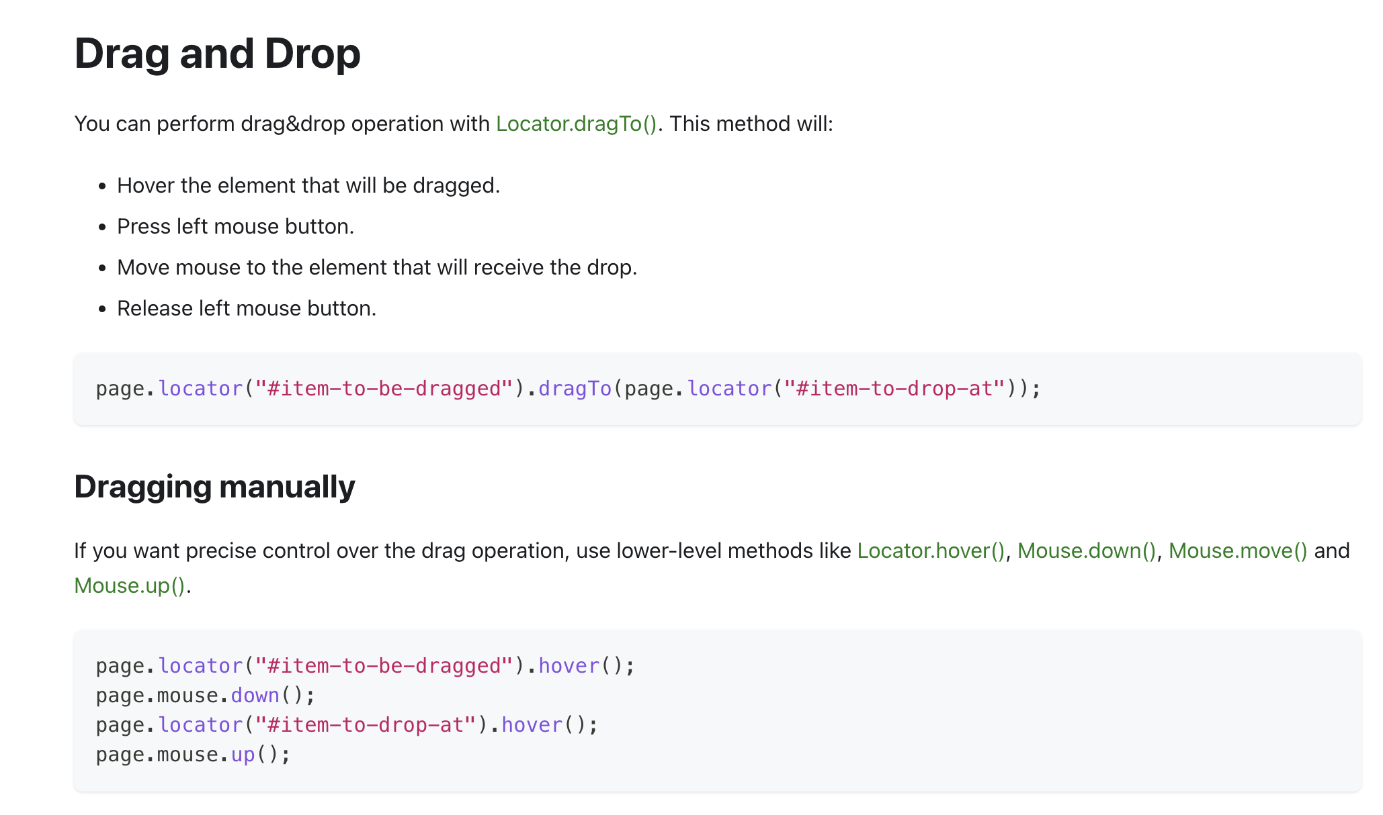

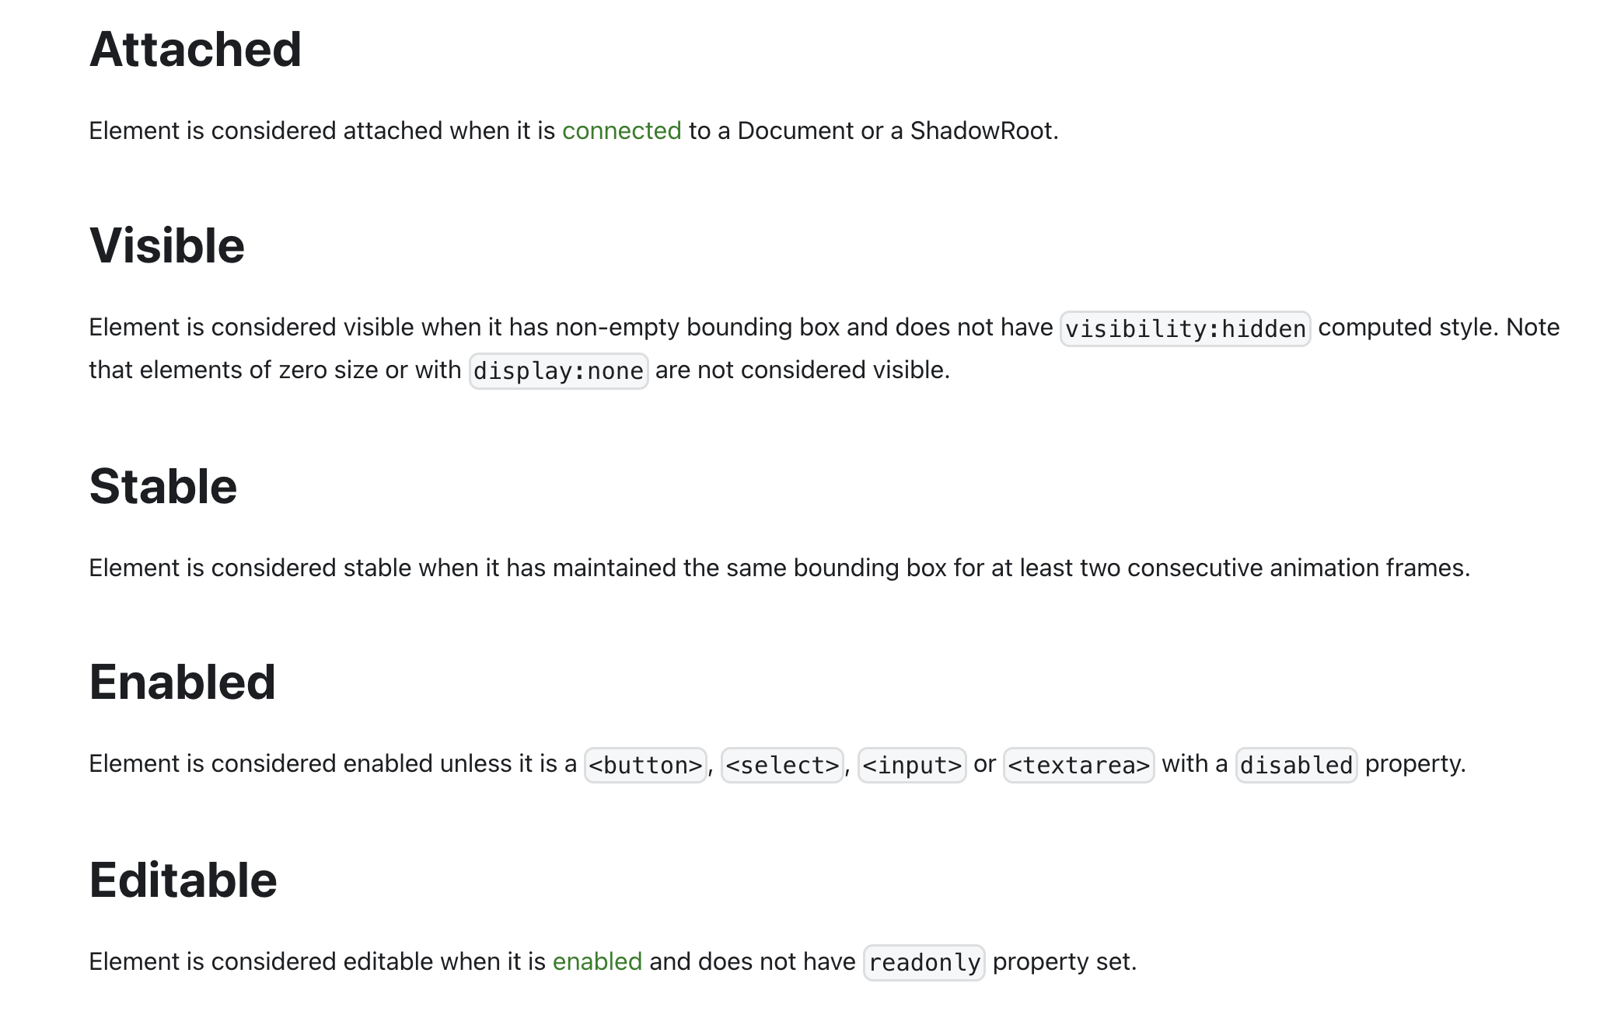

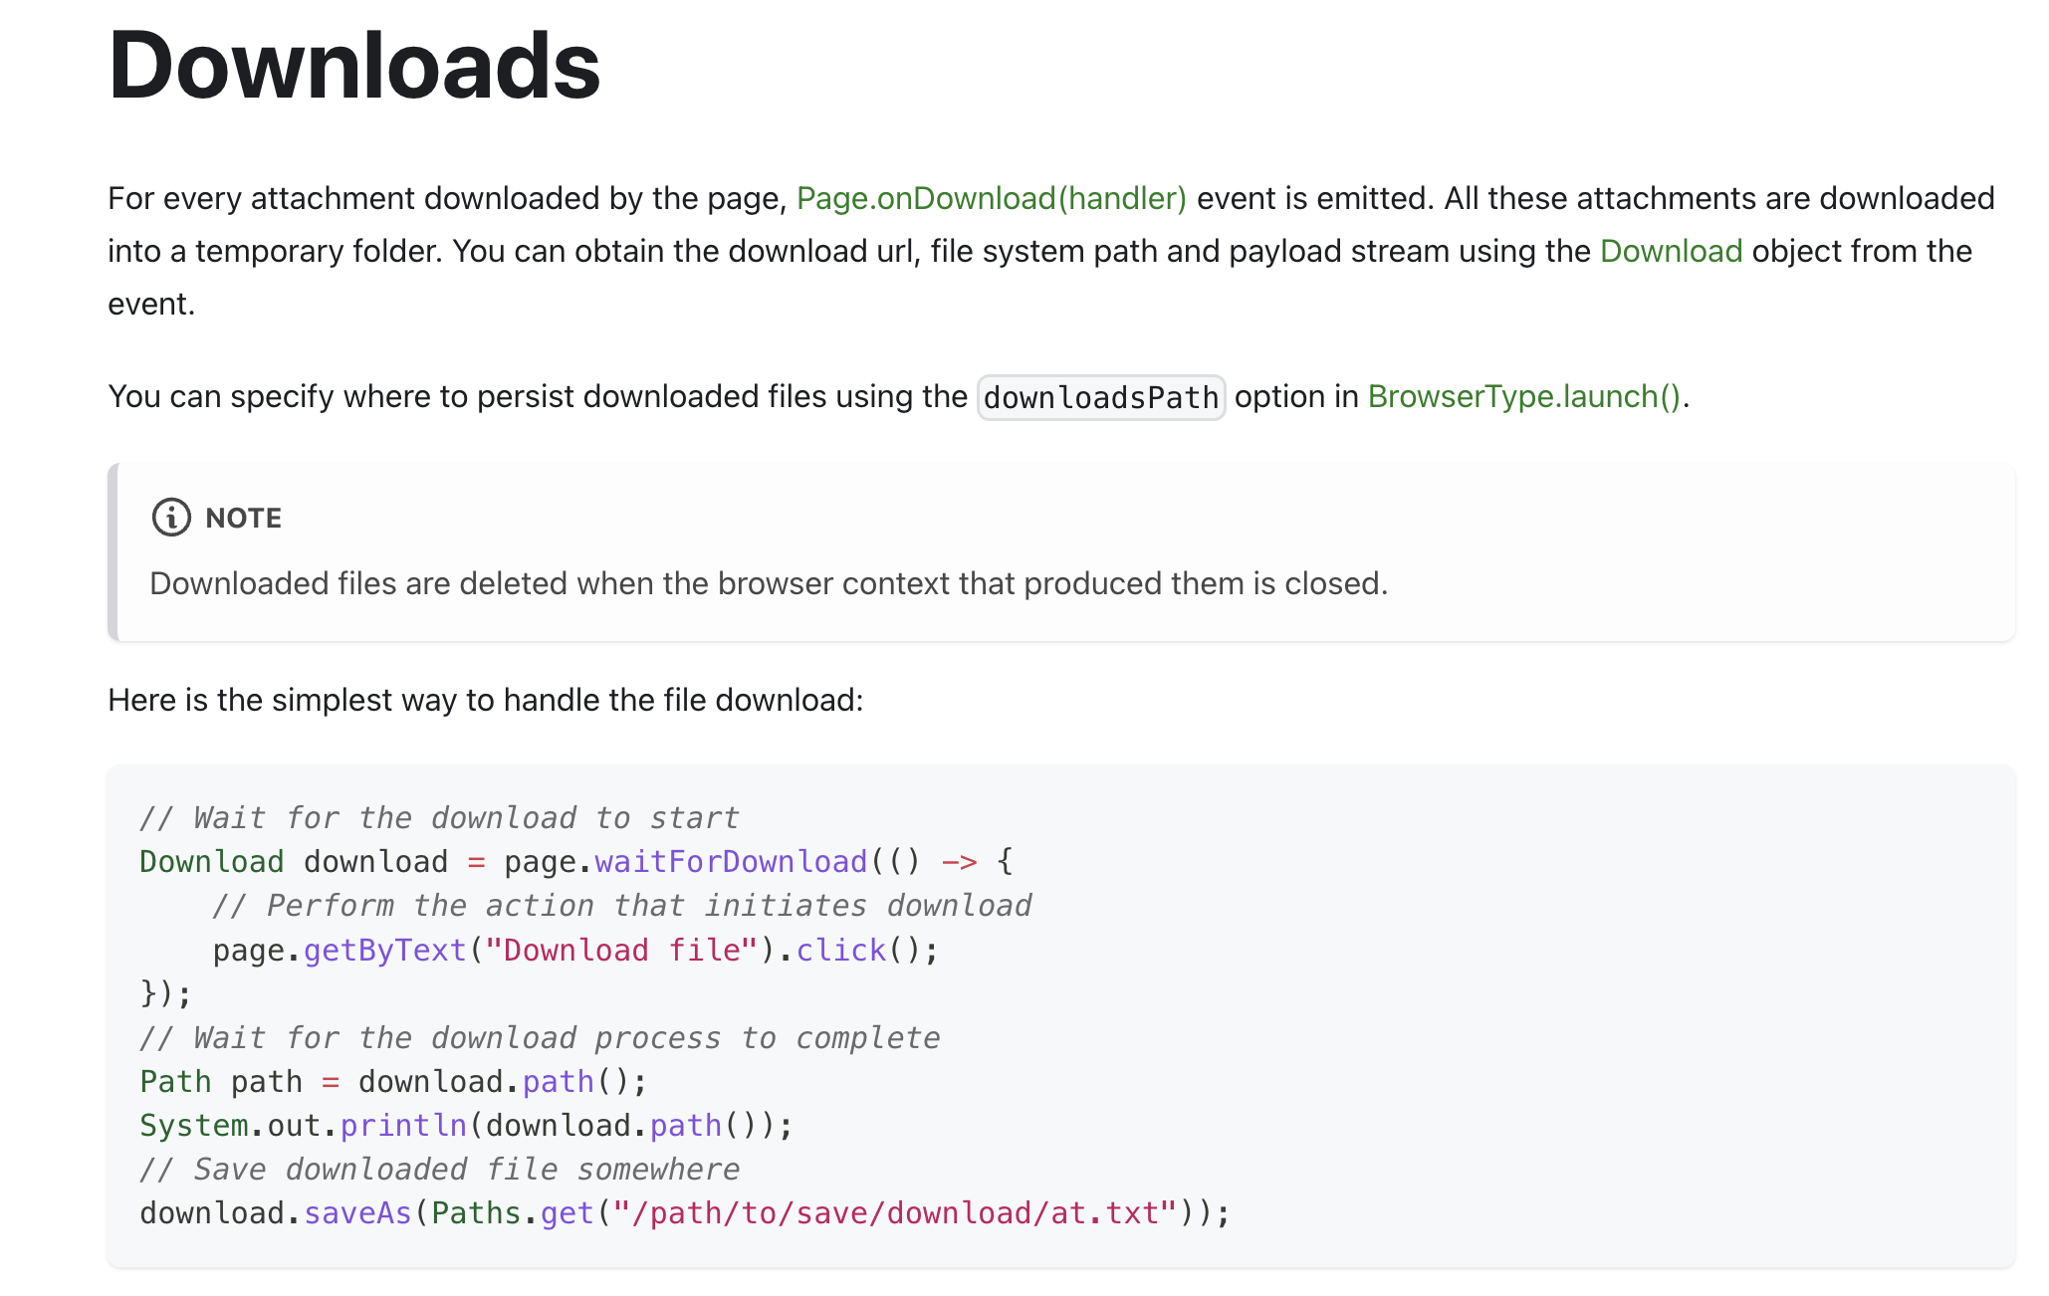

**How to handle alerts**

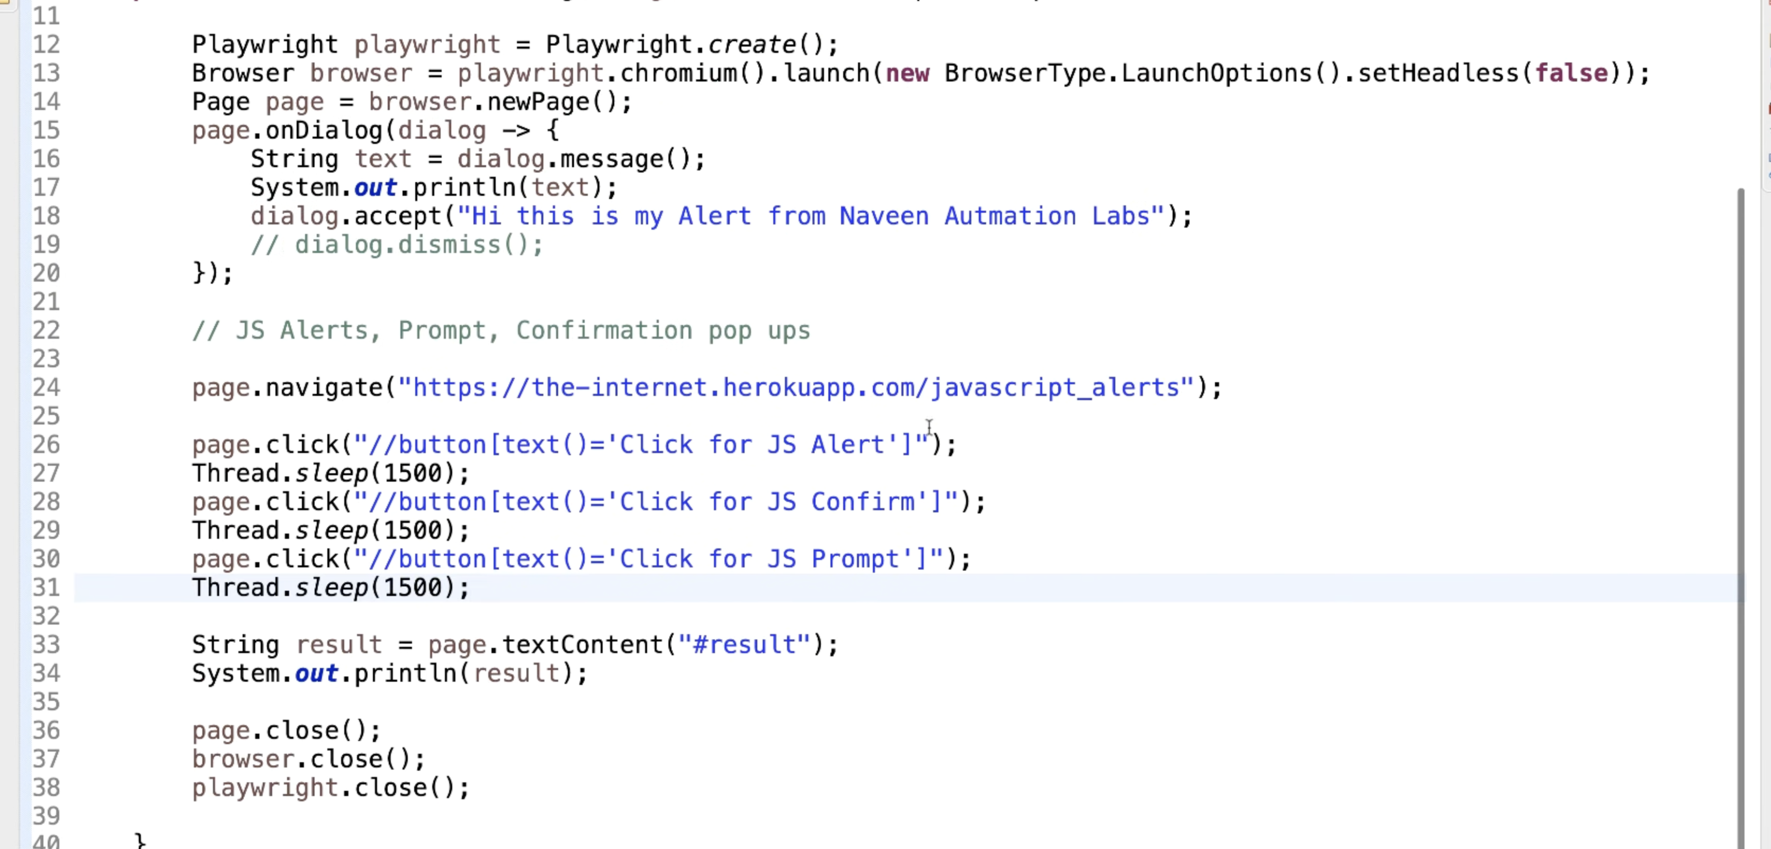

**How to handle frames**

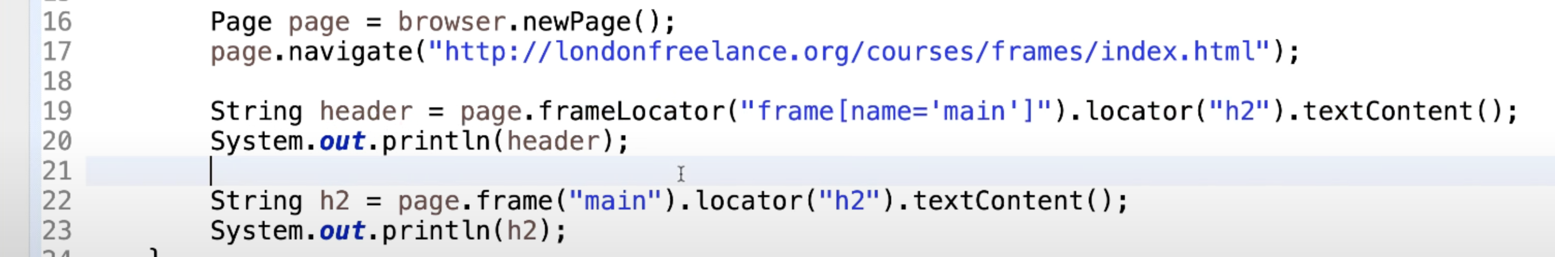

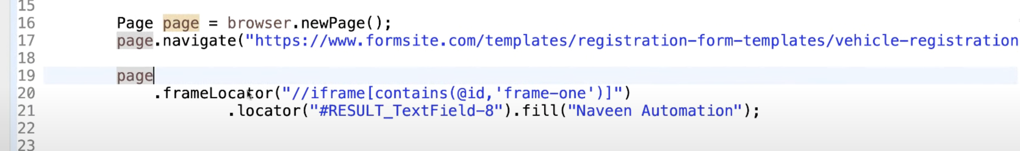

**How to handle tab/window**

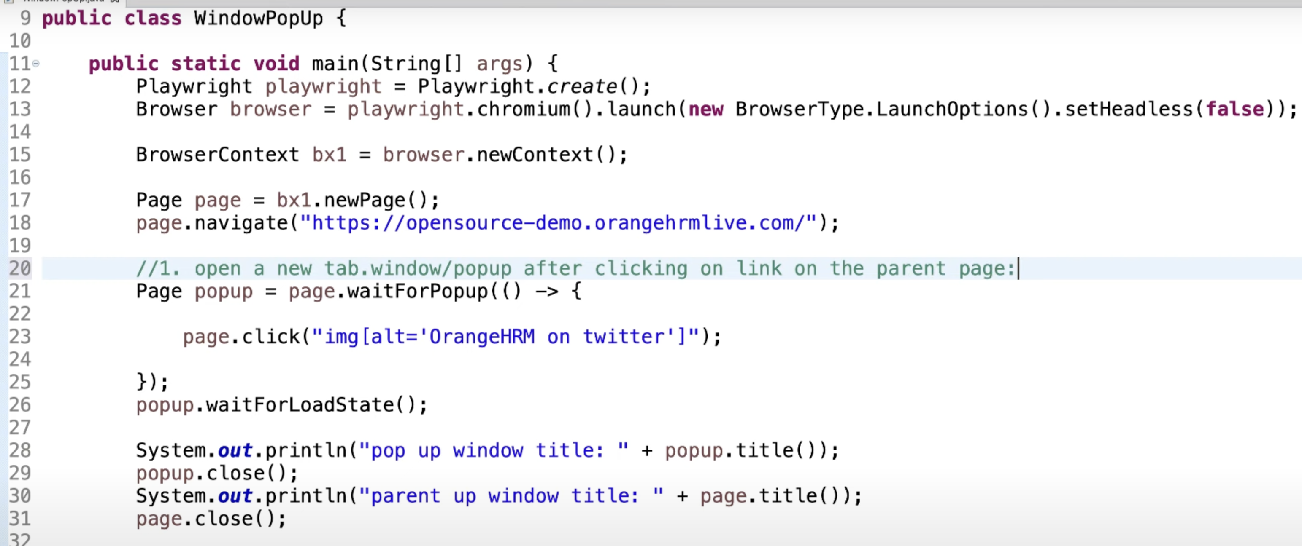

**When we want to open blank window/tab**

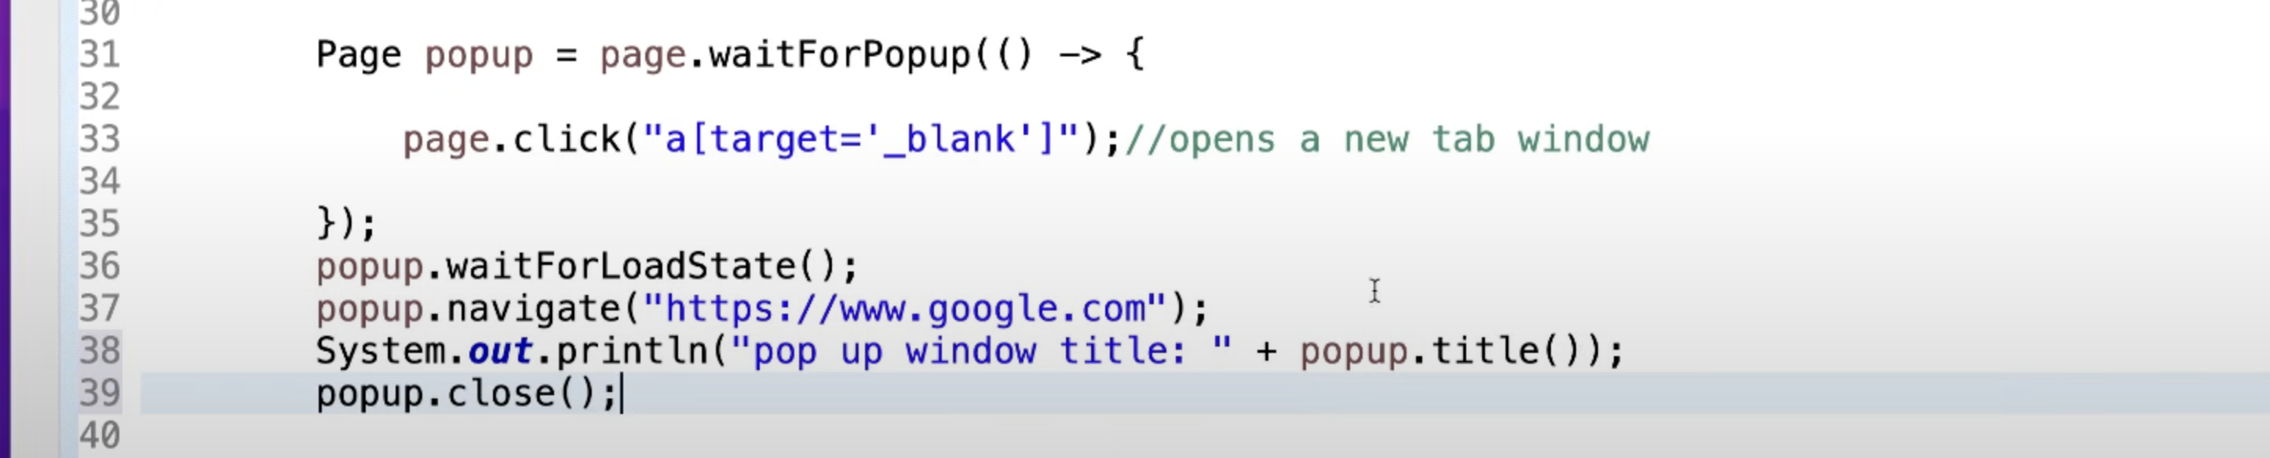

**How to handle webtable, autosuggestion, mousehover**

* Find all the rows using locator.
* Using this locator, find another locator, which we can identify using some unique value and that will be our scope.
* Then find locator, where we want to perform some action.

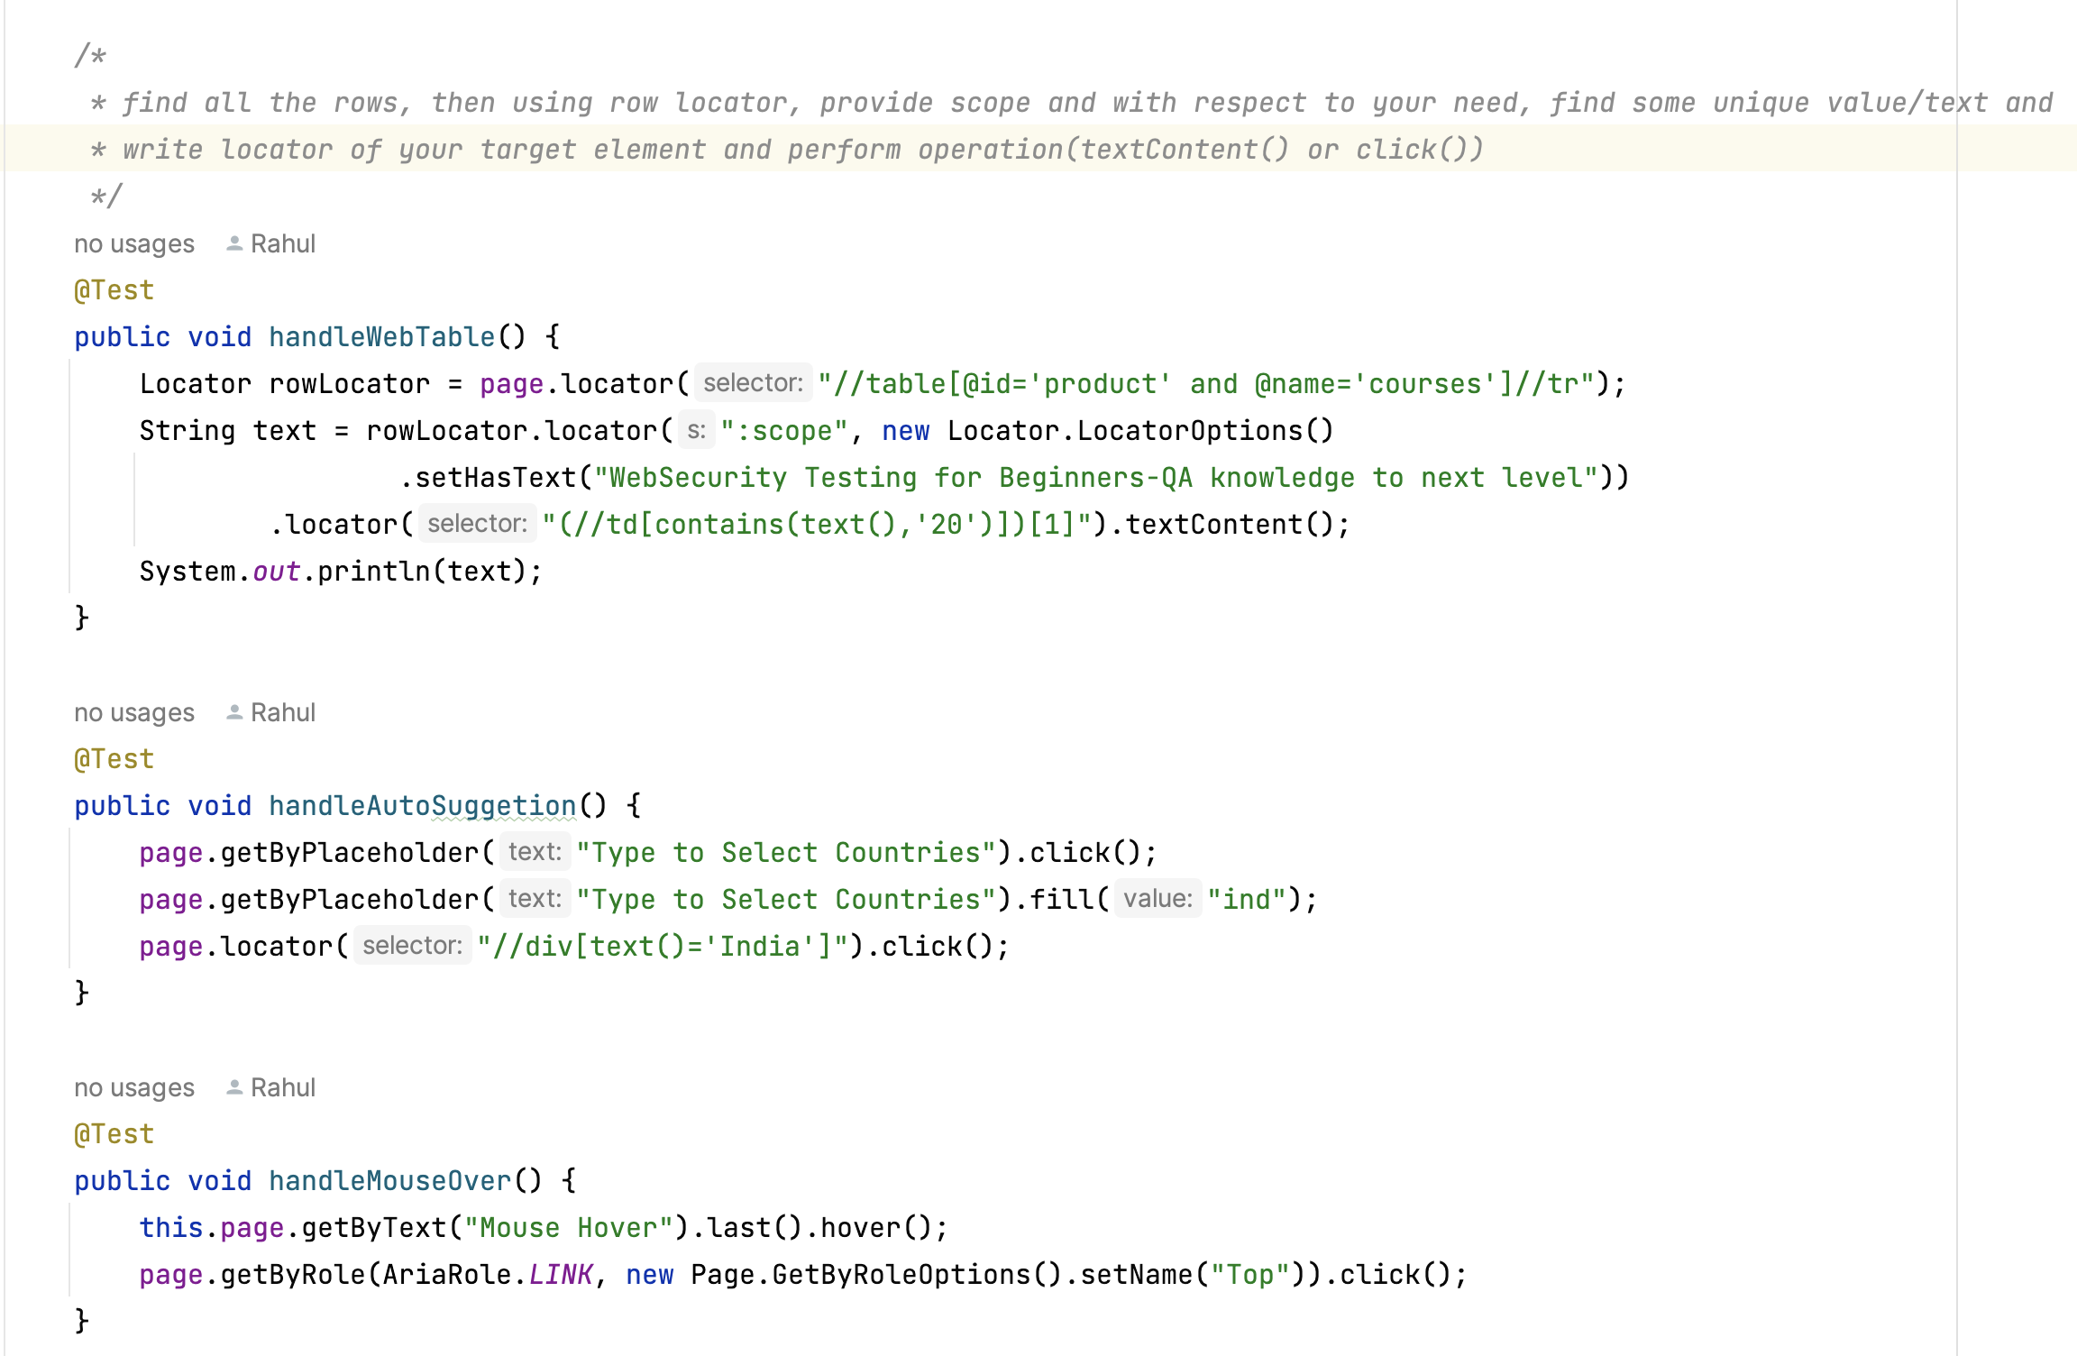

**Cross browser**

